Required tools for setup of unit testing for react Apps,

We usually JEST framework for unit test.

After installing Jest we can type npm test to test the unit tests present in the application.

Writing our first test.

Write tests as close as possible to the file.

Consider a dummy component to write unit tests.

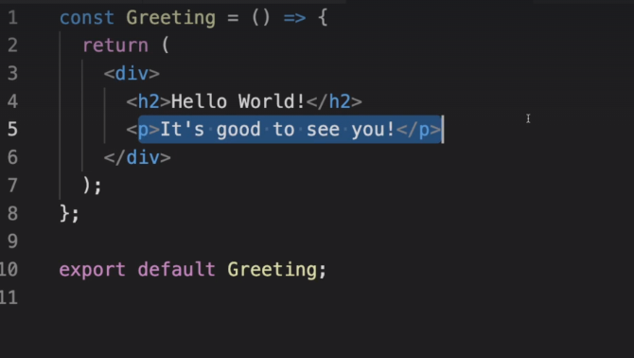

Following is the test file for that component.

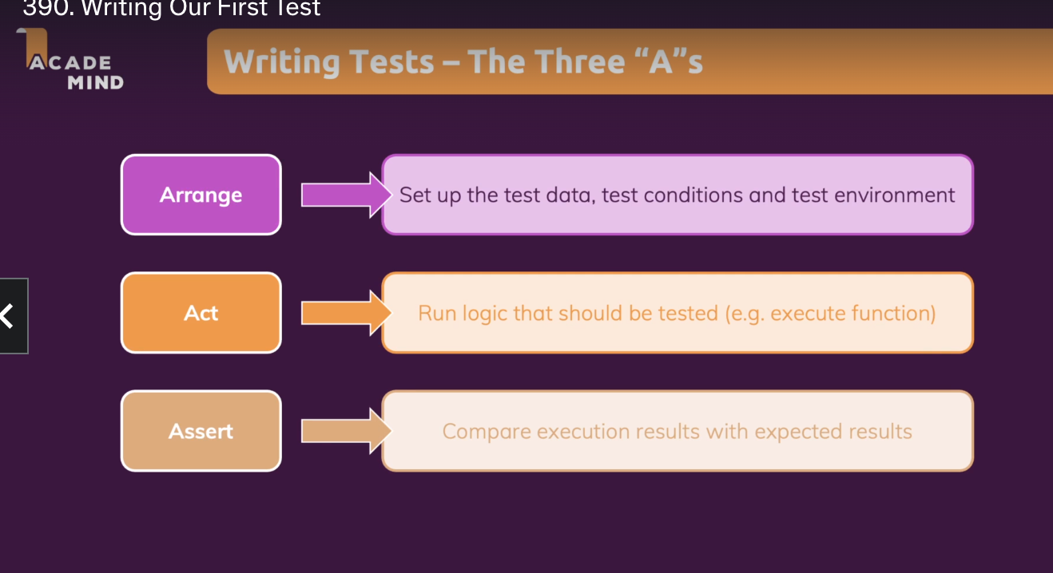

Following code checks if the element is present in the DOM node or not.

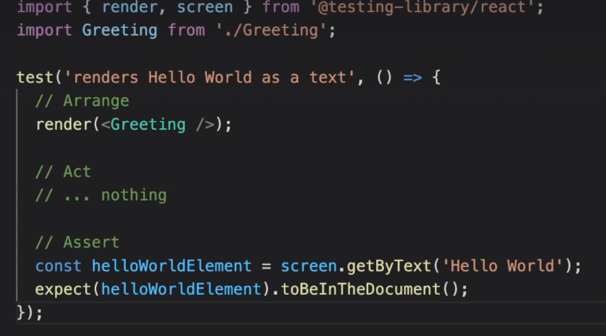

We use describe for integrating different tests suites so that all the related tests are grouped together.

How to test states in react?

Consider below file as an example for testing the state of the components:-

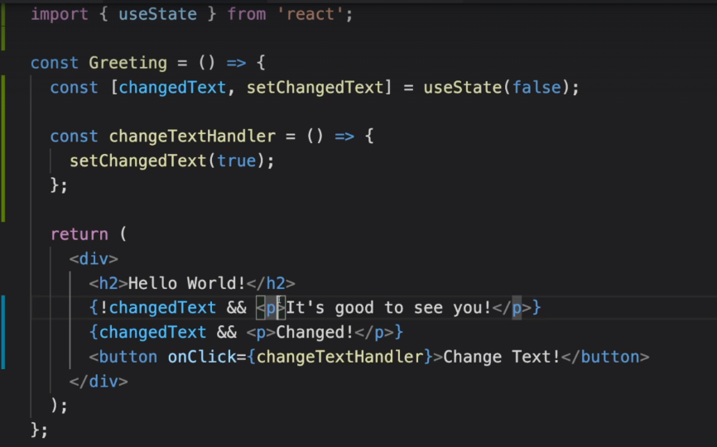

Now we want to test both the cases when button clicked and button not clicked.

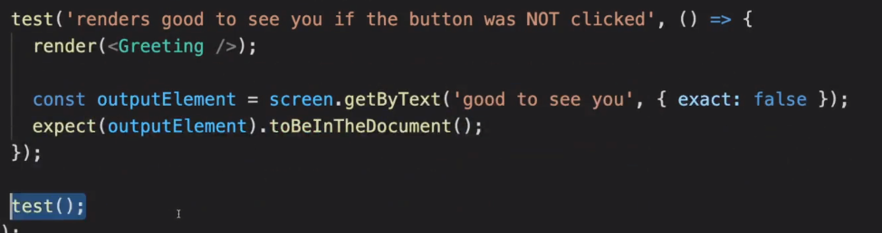

For testing user events like button click and so on we need to import userEvent from testing library.

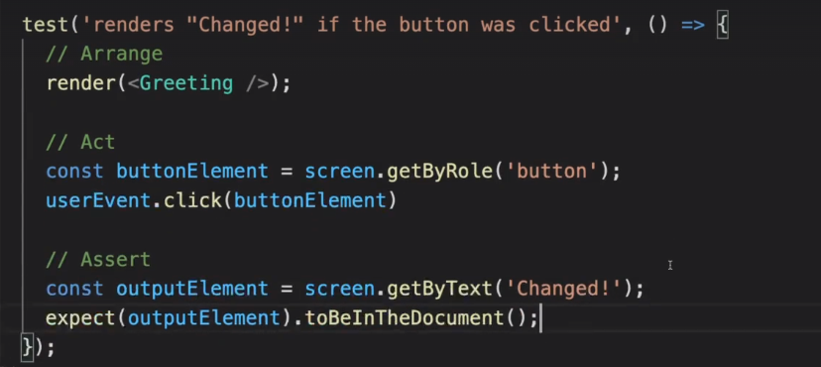

One more test case is missing here we dont want the other text to be seen when user clicks on the button.

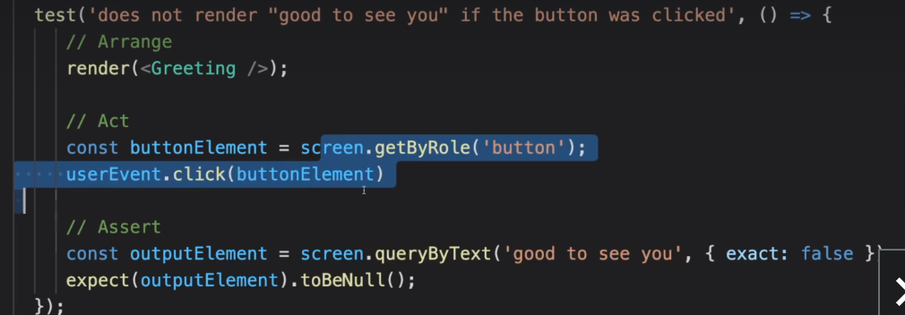

How to test connected components?( for example props)

Render automatically tests wrapper components.

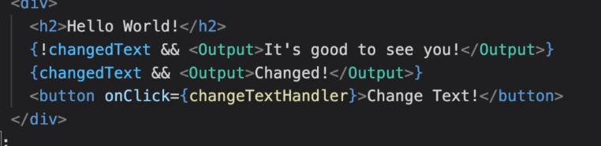

render(<Greeting></Greeting>) will automatically take care of this.

How to test async code?

Lets take a below example:-

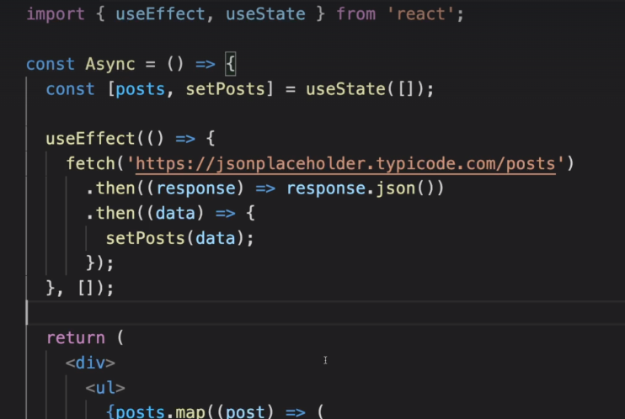

For async calls we use findAllByRole instead of getAllByRoles.

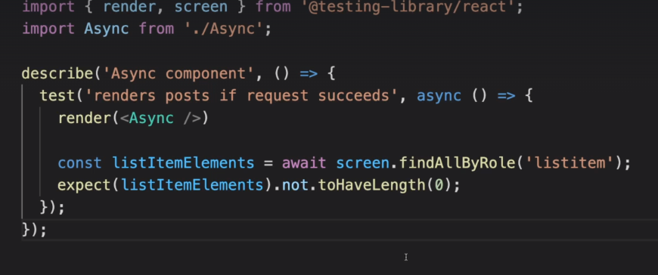

How to mock ? (Usualy we dont hammer API calls with requests because that leads to unnecessary traffic also we dont want to send requests to server) so dont request to server in the first place. So it is always a better idea to mock the API calls in this case fetch() function.

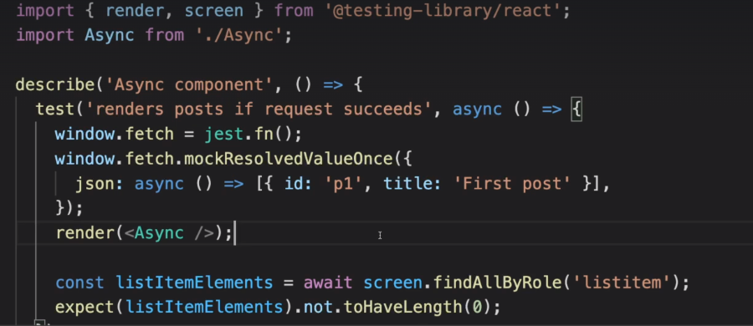

Review JEST documentation for testing library.